

**Mortgages, housing and monetary policy – what lies ahead?**

Speech given by

David Miles, External Member of the Monetary Policy Committee, Bank of England

To the Northern Housing Consortium, York Racecourse 22 November 2011

I would like to thank Jochen Schanz and Arpad Moritz for research assistance, and others for helpful comments. The views expressed are my own and do not necessarily reflect those of the Bank of England or other members of the Monetary Policy Committee.

# Introduction

Many years ago I wrote a book with the less than memorable title: “Housing, Financial Markets and the Wider Economy”. It would be a lie to say that it is available in all good bookshops. It would be more accurate to say that it might now be found in one or two second-hand book shops – though I do not know where they are1. That book had one line in it that I still rather like. It happens to be the first line of the book and one of the shorter sentences in it. And – unlike most of the rest of the book – it does not have equations or mathematical symbols. It is:

“Few people are nomads by choice”

The rest of the book could not keep up that degree of succinctness. The short, opening sentence expresses something important about our preferences: most people put great value on having a home that they can reliably call home for many years. This is one reason why the majority of people want to own their home. It is a mild paradox that despite this desire for stability and predictability in one’s housing, housing markets and mortgage markets have been close to the centre of the economic and financial turmoil we have lived through over the past four years. In many countries – a big one like the US and a small one like Ireland – what happened in the housing market was at the very heart of the problems.

As we emerge from this turmoil the housing and mortgage markets across many countries look dramatically different from how they were in 2006 and early 2007. They may never look quite the same again. I want to explore how this might play out and the link between the housing market, the mortgage market and the wider economy, both in the short run and in the longer run. Those links affect, and are affected by, monetary policy and I want to say something about that too.

# The current environment

The housing market in the UK is going through an extraordinary period of adjustment – perhaps it would be better to call it a transformation. The volume of transactions has halved since mid-2007 (Chart 1). The average level of real house prices has declined by about 20% since the peak in September 2007 – a peak that is aligned with the demise of Northern Rock, which is surely not a coincidence (Chart 2). Since then housing starts have fallen by half (Chart 3). And the net flow of mortgage lending has collapsed to almost zero (Chart 4).

1 I have found 3 copies on Amazon. One is described as in “good condition” and the quoted price is £36.95. One is described as being in “very good” condition and has a quoted price of 90p.

# Chart 1: Monthly number of houses sold(a)

Thousands

160

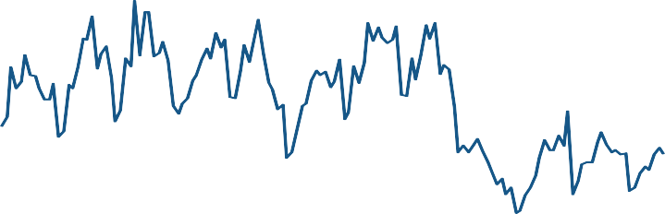

140

120

100

80

60

40

20

0

00 02 04 06 08 10

Source: HM Land Registry.

(a) Data covers England and Wales. Non seasonally adjusted.

# Chart 2: Average house prices in today’s terms(a)

£ thousands

250

200

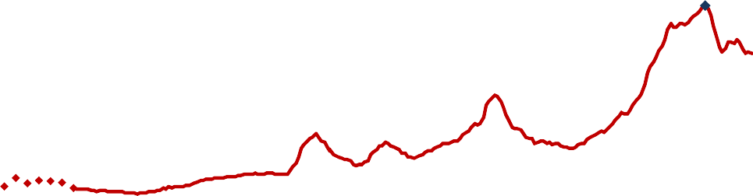

Sept. 07

150

100

50

0

1946 1951 1956 1961 1966 1971 1976 1981 1986 1991 1996 2001 2006

Sources: DCLG, Nationwide, ONS.

(a) From 1952 Q4 Nationwide nominal house price data, using the Office for National Statistics Retail Price Index (RPI) to convert past nominal prices to current (2011 Q3) values. Up to 1952 DCLG house price data converted to current (2011 Q3) values. Not seasonally adjusted.

# Chart 3: Number of housing starts(a)

Thousands

200

180

160

140

120

100

80

60

40

20

0

00 01 02 03 04 05 06 07 08 09 10

Source: DCLG.

(a) Annual number of housing starts by private enterprises, local authorities and registered social landlords.

# Chart 4: Net flow of mortgage lending(a)

£bn

12

10

8

6

4

2

0

‐2

93 95 97 99 01 03 05 07 09 11

Source: Bank of England.

(a) Monthly changes of total sterling net secured lending to individuals and housing associations. Seasonally adjusted.

The decline in housing market activity occurred despite an unprecedented reduction in the Bank of England’s key interest rate (Bank Rate) to 0.5% in March 2009, to the lowest level – by far – in the over 300-year history of the Bank. It has remained there since. Implied forecasts of Bank Rate based on prices of interest rate instruments suggest that even by the Autumn of 2014, the level of Bank Rate will only be around 1% (Chart 5). I think it is fair to say that virtually no-one (perhaps literally no-one) anticipated all this at the start of 2007.

# Chart 5: Historical Bank Rate and market-implied expectations(a)

Per cent

7

Bank Rate

OIS Forward

6

5

4

3

2

1

0

07 09 11 13 15

Sources: Bloomberg, Bank of England and Bank of England calculations.

(a) Instantaneous forward rates derived from the Bank’s overnight index swap (OIS) curves. Data as of 10 November 2011.

These developments reflect the scale of the financial crisis. Right from the beginning of this crisis, the housing market was at the centre. By mid-2007, the proportion of delinquencies among subprime mortgages had increased considerably in the US. Investors in mortgage-backed securities started to mistrust the quality of banks’ lending policies. Issuance of securities backed by mortgages plummeted, and not just in the US; it happened in the UK. Banks that had relied on securitization as a form of funding of mortgage lending found themselves short of liquidity. Uncertainty spread as to which banks were most exposed to mortgage losses, or exposed to another bank which itself was likely to suffer losses from mortgage exposures. Banks ceased to trust each others’ ability to repay their debt and were only willing to lend to each other at very short maturities, if at all. The crisis had started.

Its first very widely visible manifestation in the UK came in September 2007, when the Bank of England provided Northern Rock with liquidity support and there was a retail run on that bank. In February 2008, Northern Rock was taken into public ownership.

In the four years since then the UK has been through an exceptionally severe recession. The level of real GDP has fallen by about 4% since its pre-crisis peak in 2007 and remains well over 10% below its pre-crisis trend path (Chart 6). After some recovery during 2009 and 2010, growth has fallen back to close to zero.

The unemployment rate has increased from just over 5% at the end of 2007 to 8% (Chart 7).

# Chart 6: UK real GDP, indexed to peak(a)

110

Real GDP (a)

Pre‐crisis trend of real GDP (b)

105

100

Indices, 2008 Q1=100%

95

90

85

80

75

01 03 05 07 09 11

Source: ONS, Bank of England calculations.

1. Seasonally adjusted chained volume measures at market prices, indexed to 2008 Q1 = 100%.
2. Linear trend fitted to 1999 Q3 to 2008 Q3 real GDP index data and extrapolated to the period between 2008 Q3 and 2011 Q3.

# Chart 7: Unemployment rate(a)

per cent

12

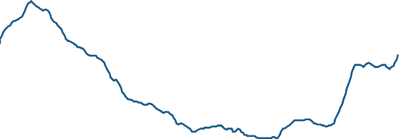

10

8

6

4

2

0

91 93 95 97 99 01 03 05 07 09 11

Sources: Labour Force Survey, Bank of England calculations.

(a) Backward-looking three-month moving averages.

It is not surprising that the recession and the financial stresses have had a huge impact on the housing market. The real disposable income of the majority of households has fallen significantly; uncertainty about future levels of incomes has increased sharply. Uncertainty pushes down on the value of long-lived assets, and few assets are as long-lived as houses.

I believe that it is likely that we will get back – maybe slowly – to more normal rates of economic growth and that households’ uncertainty about the future will fall back. And as that happens monetary policy will move back to a more normal setting. But I do not believe that the housing market and the mortgage market will get back to where we were in the years leading up to the crisis. I also do not think we should regret that. To see why I think it is useful to look at some fundamental features of how people finance home-ownership.

# Transition to a more resilient housing market

When people buy their first house they typically finance the majority of the purchase with debt. But looking across all home-owners, the average level of leverage does not appear high. In the UK now gross housing wealth is about £4trn; the stock of mortgages is around £1.2trn. Average leverage, defined as gross housing wealth over housing equity, is a bit under 1.5 (£4trn / (£4trn - £1.2trn)=1.43). This is below the average leverage of non-financial corporations which is close to 2. But the average leverage figure in part reflects the fact that many houses have no mortgage on them – the owners have either repaid the mortgages on them or were cash buyers. At the other end of the spectrum are first-time buyers, who tend to be highly levered.

Until 2007, about half of all first-time buyers took out mortgages with loan-to-value ratios of 90% or more - that is, leverage was 10 or higher for half of all first-time buyers (Chart 8). And house-price to

income, as well as loan-to-income, ratios had increased sharply over the previous decade (Chart 9). This reflected ten years over which house prices were rising far faster than the average households’ disposable income (Chart 10).

# Chart 8: Median loan-to-value ratios for first-time buyers(a)

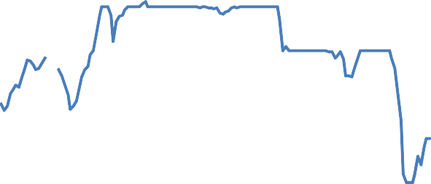

Per cent

100

95

90

85

80

75

70

Source: CML

1974

1979

1984

1989

1994

1999

2004

2009

(a) Data are not available for 1978. The vertical lines represent breaks in the series.

It is worth noting that this age profile of leverage amongst home-owners – very high leverage for young home-owners and very low leverage for older people – is quite different from what one observes with many companies. Start-up companies are often largely equity financed; many more established companies have greater access to debt.

# Chart 9: Median loan-to-income ratios for first-time buyers(a)

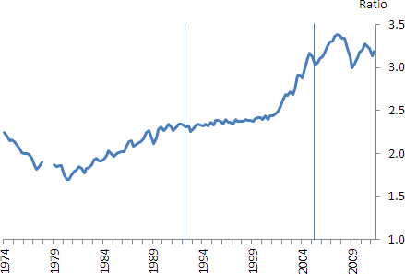

Source: CML

(a) Data are not available for 1978. The vertical lines represent breaks in the series.

# Chart 10: House price(a) / Household disposable income(b) ratio

Ratio

7

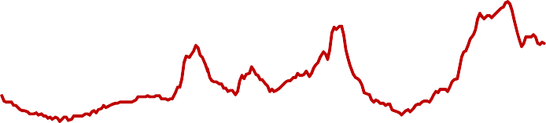

6

5

4

3

2

1

0

1950 1955 1960 1965 1970 1975 1980 1985 1990 1995 2000 2005 2010

Sources: Nationwide, ONS, Miles, D. Housing, Financial Markets and the Wider Economy, 1994 and Bank of England calculations.

1. Using Nationwide house price data.
2. Total household disposable income divided by the number of households. Household numbers are based on census data, linearly extrapolated for non census years.

High leverage, combined with a high debt-to-income ratio, makes new buyers vulnerable to a shock to income and to a reduction in house prices. Once banks and, crucially, those that fund banks, no longer believed that rising nominal house prices were overwhelmingly the most likely outcome, the pricing and availability of mortgages to new buyers that we had got used to in the years up to 2007 was no longer sustainable. That point was reached rather suddenly in the UK in the autumn of 2007. House prices then began to fall as funding for mortgage lending became more difficult for banks. Affordability criteria were tightened.2 The median LTV ratio for first time buyers fell sharply to 75%, and has only risen to 80% more recently.

Banks and building societies are now requiring that house purchases are financed with more equity. Curiously enough, they thereby apply exactly the same logic against which some have lobbied hard when banking regulators drafted tighter rules for bank capital. If banks are financed to a greater degree by equity, the banking system will be more stable. Similarly, a greater share of equity finance should increase the stability of the housing market: more equity finance means that the likelihood of arrears on debt, personal insolvencies and forced sales of homes, which tends to lead to more volatile prices, is reduced.

The natural place for equity to come from is owners themselves. But it is not the only source of equity.

The most straightforward option is for prospective buyers to postpone their purchase, while they save more to accumulate a larger deposit. As a result the average age at which people would buy their first home will rise, and the share of owner occupied houses will fall. The change in the pattern of home ownership this generates can be expected to be very large.

Consider the following, stylized, example. Imagine we start in a world where it is possible for a first-time buyer to borrow 95% of the value of a property. Suppose prospective homeowners typically start saving for the deposit on their first property when they are 28 years old, that they save 5% of their annual income and that the average price of properties bought by first time buyers is four times their annual income at the point they buy. Then it takes four years for prospective buyers to accumulate a deposit of 5% of the average house price.3 In this example, the average age of first time buyers is 32 years assuming that they only need to have a deposit of 5% – as was quite usual before the crisis. Now think what happens when banks require a deposit of 20%. Assuming no change in saving behaviour, it takes four times as long to save the deposit (16 years). The average age of a first-time buyer would then rise to 28 + 16 = 44 years. The solid line in Chart 11 shows the relationship between the required deposit on the x-axis and the age of first-time buyers assuming no change in saving rates.

It is more likely that those wishing to buy try to save more. The dotted line in Chart 11 shows what would happen to the age at which people buy if they increase their saving rate from 5% as the required deposit

2 The Financial Services Authority has recently reviewed mortgage lending practices and proposed a set of criteria against which mortgage lenders would be required to assess the affordability of the mortgage. See [http://www.fsa.gov.uk/pages/About/What/mmr/index.shtml.](http://www.fsa.gov.uk/pages/About/What/mmr/index.shtml)

3 We implicitly assume that incomes and house prices tend to rise in line and at a rate roughly equal to the return on savings.

rises, up to a saving rate of 10%. The dotted line shows what happens if having doubled the saving rate potential home-owners cannot save any more. This would mean that it takes eight years for the average first-time buyer to save 20% deposit and so the average age at the time of first purchase is 36 years.

# Chart 11: Stylized example: Increase in age at time of first purchase (a)

Unchanged saving rate of 5%

80

70

Saving rate increases with minimum deposit in

the 5 to 10% range, and remains 10% above

60

50

40

30

20

10

0

0% 5% 10% 15% 20% 25% 30% 35% 40% 45% 50%

Minimum deposit

Age at time of first purchase

Source: own calculations.

(a) Assumptions: The average house for the average first time buyer costs four times annual income. Representative first time buyers start saving from age 28 and the savings rate is 5% of their annual income.

A sudden transition to a situation where the average age of first-time buyers is significantly higher is particularly difficult because for some years the flow of new buyers falls very sharply, before recovering. This has major impacts on house builders. Recently announced government policies to help people buy new properties with a lower deposit are designed to help offset this and ease the transition4. But I want to think about the longer-term implications of first-time buyers typically being older. To do so let me continue with the simple stylised example.

As people buy houses later, the owner-occupation rate tends to fall. Assume we have a constant population and that people leave home at age 20 to rent, buy their first property as soon as their savings permit, and then stay in owner-occupation until, say, age 75. Everyone (sadly) then moves back into the non-owner occupied sector for the last 5 years of an 80 year life. In this stylized example the proportion of adults (that is people aged 20 to 80) who are owner occupiers falls by around 7 percentage points for every additional 5% deposit lenders require, assuming no change in saving rates. For example, if the required deposit is 5%, and people typically buy their first property when they are 32, the owner occupation rate is:

(75-32) / (80-20) = 43/60 = 71%

4 “Laying the Foundations: A Housing Strategy for England”. HM Government, November 2011.

When the required deposit rises to 20%, and people buy their first property when they are 44, the owner occupation rate is:

(75-44) / (80-20) = 31/60 = 52%

The solid line in Chart 12 illustrates this for the case of a constant savings rate; the dotted line for the case in which the savings rate increases with required deposits up to a maximum saving rate of 10%. With the higher saving rate the owner occupation would fall to 65%.

# Chart 12: Stylized example: decline in owner-occupier rate (a)

Unchanged saving rate of 5%

90%

80%

70%

60%

50%

40%

30%

20%

10%

0%

Saving rate increases with minimum deposit in

the 5 to 10% range, and remains 10% above

0% 5% 10% 15% 20% 25% 30% 35% 40% 45% 50%

Minimum deposit

Owner‐occupier rate

Source: own calculations.

(a) Assumptions: The house for the average first time buyer costs four times his annual income. Representative first time buyers start saving from age 28. People leave home at 20 to rent and move back to the non-owner occupied sector from age 75.

The increase in the age of first-time buyers and the decline in the owner-occupation rate in this example look very substantial, even if potential first-time buyers can double their saving rate over an extended period. But this is because the required equity is only provided by the prospective home-owners themselves. That is not the only way forward. Again, consider the analogy to bank capital. To increase their equity, banks can save by retaining profit instead of paying dividends. Or, they can offer new equity shares. It may take time to build capital by accumulating earnings; but issuing shares increases bank capital immediately.

We can hardly expect prospective first-time buyers to issue shares on the London Stock Exchange. But there are feasible contracts which are a bit like issuing shares.

One variant is shared ownership schemes, in which the buyer acquires only a share of the home and pays rent on the fraction owned by the (outside) equity provider. This reduces the buyer’s exposure to changes in the value of the house because they only own a fraction of it. And it *may* reduce their monthly cash outflows if the rent is lower than the increase in the monthly mortgage payments had they bought the entire house.

The buyer’s leverage and debt-to-income ratios are lower than if they acquired 100% of the property, financed by a deposit and traditional mortgage. The buyer may have the option to increase their share in the ownership when they have accumulated further savings. Under the schemes that exist today the ownership of the part the occupier does not own typically lies with government or property developers, or both.

Another variant are so-called equity loans. In contrast to shared ownership schemes, the buyer retains the ownership of the entire property5. But those who provide equity loans accept some of the risk – both upside and downside – that the value of the house changes. Effectively the interest rate on the loan becomes linked to the evolution of the value of the house. Finance experts would probably describe equity loans as hybrid instruments, with characteristics somewhere between straightforward debt and equity.

An equity loan enables a buyer to take out a smaller traditional mortgage. They might obtain this mortgage at a lower interest rate because the mortgage bank’s risk has fallen: the bank is protected against house price falls not only by the homeowner’s deposit, but also by the equity loan.

Of course, the provider of the equity loan requires a return. For investors in hybrid instruments in firms, this compensation usually comes in the form of some contractual payments during and at the end of the maturity of the investment. These contractual payments can be quite low if investors also expect that their stake might gain in value over time. Similarly, the provider of an equity loan might require regular payments from the homeowner. But such regular payments may not be necessary so long as the final payment is adjusted up. In the case of equity loans, this final payment typically depends on the terminal value of the property. So in exchange for taking a higher share of a capital gain on a property a provider of an equity loan might agree to receive no payments until the property is sold (or at least up until some set date).

Consider the following example. An investor provides an equity loan of £10,000 for a house worth £100,000. In exchange for paying no annual return on this loan the homeowner agrees to give up 20% of any gain in the value of the home and the loan provider agrees to take 10% of any loss in the value of the house. Five years later the homeowner decides to sell the house. If the house at that point is worth £135,000, they repay the investor the initial £10,000 plus 20% of the £35,000 gain in the value of his house, that is, £17,000 in total. If, instead, the house is worth only £80,000, they repay the investor the initial £10,000 less 10% of the

£20,000 loss in the value of his house, a total repayment of £8,000. Were both price movements equally likely, the investor would expect to receive ½*(£17,000) + ½*(£8,000) = £12,500 on an initial investment of

£10,000. This is an expected return of 25% over five years.

Figuring out what share in the upside (rises in house values) and the downside (falls in house values) the provider of an equity loan would need to take to make it a reasonable deal – given that the loan pays no regular interest – is not straightforward. It depends on the probabilities of house price changes over long

5 Shared equity schemes and equity loans are offered as part of the UK government’s affordable housing schemes.

periods. And there are a continuum of contracts that could be acceptable to lenders, some of which have smaller shares of the upside but also smaller shares of the downside. In the example above – and if we assume that we somehow know that the only two, equally probably outcomes are the house falls to £80,000 or rises to £135,000 in value – we can work out what such contracts look like. If, as in the example above, we assume people need to earn an expected return of 25% on a loan of £10,000 any pair of values of x and y that satisfy this equation work:

½ *y*£35,000 - ½*x*£20,000 = £2,500

So that: y = [2 * 2,500 + x * 20,000]/35,000

where y is the share of any upside that the provider of the equity loan takes and x is the share of any downside. Chart 13 shows combinations of possible upside and downside shares, which generate the required return to the provider of the equity loan.

We have seen that y= 20% and x = 10% work. So do y = 33% and x = 33% or y=40% and x = 45%. It is possible in this example to share upside and downside risks equally, but also for home-owners to hand more of any losses over than they hand over of any gains.

# Chart 13: Stylized example of equity loan – neutral upside and downside shares of investor(a)

80.0%

70.0%

60.0%

50.0%

40.0%

30.0%

20.0%

10.0%

0.0%

0% 10% 20% 30% 40% 50% 60% 70% 80% 90% 100%

**Downside shares**

**Upside shares**

Source: own calculations.

1. Assumptions: Equity loan is 10% of house value. Equal probability of 20% fall and 35% rise in the value of property. Required rate of return on equity loan is 25%.

A more realistic example would be one where house price changes follow a normal distribution. The table below shows combinations of upside and downside shares due to an equity lender where the percentage change in the value of a house follows a normal distribution with a mean of 10% and a standard deviation of

20% over five years. We assume that the required expected (or average) return is 25% over five years. In this example we consider a loan worth 20% of the value of a property:

# Table 1: Stylized example of equity loan – neutral upside and downside shares of investor(a)

|  |  |  |  |  |  |  |  |  |  |  |
| --- | --- | --- | --- | --- | --- | --- | --- | --- | --- | --- |
| **Share of upside** | 36% | 39% | 42% | 45% | 48% | 52% | 55% | 58% | 61% | 64% |
| **Share of downside** | 0% | 11% | 22% | 32% | 43% | 57% | 68% | 78% | 89% | 100% |

Source: own calculations.

* 1. Assumptions: Equity loan is 20% of house value. Percentage change in house price value over 5 years follows a normal distribution with mean of 10% and standard deviation of 20%. Required rate of return on equity loan is 25% over five years.

The attractive thing about there being a continuum of contracts is that home-owners could decide how much house price risk they wanted to sell and how asymmetric the contract they were prepared to accept to reduce the monthly servicing cost of the overall debt on a property. But there are practical issues to do with the timing of people moving house and making sure that home-owners understand contracts they have entered to.

So there are many ways, in principle, for reducing leverage in house financing beyond the accumulation of more savings by each prospective buyer. Some such contracts exist already – mainly sponsored by the government. I think more will come. And they could be useful because pure debt contracts (standard mortgages) have become more difficult to get. Banks are, for understandable reasons, substantially more cautious in granting mortgage credit compared to before the crisis. Banks’ own creditors appear much more concerned about the risk of banks’ portfolio of assets than they used to be. One reflection of this is that the cost of insuring against a bank’s default has risen dramatically during the crisis (Chart 14).

# Chart 14: 5-year CDS premia for the major UK banks(a)

Basis points

300

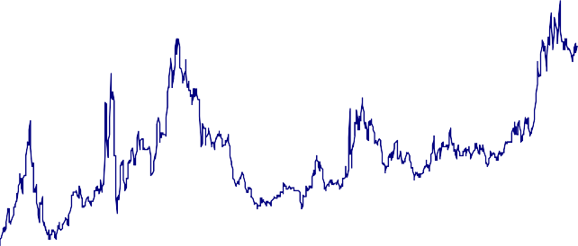

250

200

150

100

50

0

2008 2009 2010 2011

Source: Markit Group Limited.

(a) Unweighted averages of five-year, senior CDS prices of Barclays, HSBC, Lloyds Banking Group, RBS and Standard Chartered. Data are up to 14 November 2011.

The sudden tightening in mortgage availability is causing severe difficulties – most clearly in the construction sector6. In the longer run, investors may well become less concerned about banks’ risk than they are today and the cost of banks funds will fall. When this happens, I would expect to see banks becoming less

risk-averse in their own lending. Banks may then accept higher loan to value ratios on mortgage loans than today. But we are not likely to get back to where we were before the crisis. First-time buyers are likely to need to raise more equity than they did in the years before 2007. Some of that may come from outside providers of equity. But it is likely that much will need to come from buyers. It will take time for first-time buyers to accumulate larger deposits, so they will typically buy later and the share of home-ownership will be lower. But in the longer-run it is not at all clear that a lower rate of home ownership represents a big loss to society. The need to save for a larger deposit offsets incentives created by the tax system against renting and towards owner-occupation. Those tax incentives are both substantial and are a distortion.

The imputed income from home ownership – that is, the benefit derived from having a place to live in – is not taxed in the UK. Tax is different for the rental sector; landlords pay tax on rental income. Landlords can offset interest paid on loans against rents received in calculating tax. Owner-occupiers can no longer deduct mortgage interest payments from taxable income. Capital gains tax is not levied on owner-occupied housing (at least for primary residences); but it is levied on capital gains made on rented property.

These differences in the tax treatment of owner-occupied and rented property generate incentives for tenure that depend on how investments in rental property are financed. The tax incentives against renting are least when rental property is financed with debt. They are greatest when rental property is financed from equity

6 Yesterday’s policy announcements from the government are designed to address these problems. See “Laying the Foundations: A Housing Strategy for England”. H M Government, November 2011.

(e.g. when buy to let investors use accumulated savings to invest in properties to rent out – especially if those savings were in tax sheltered investments). In either case the capital gains system creates incentives that work against renting.

The reduction in the availability of debt to finance house purchase has reduced the levels of gearing on properties bought by new owner-occupiers *and* by new buy to let investors. So it is not entirely obvious how they have combined with the tax system to change the net incentives to own versus rent. But it seems to me highly likely that the negative impact on demand for owner-occupied property arising from first-time buyers needing to have a larger equity stake more than offsets the greater tax distortions against renting because potential landlords may be less able to use tax sheltered forms of finance. In fact the owner-occupation rate has been falling steadily for some years now and so it seems clear which is the stronger force.

The natural way of addressing the tax distortions is to change the tax treatment of rental versus

owner-occupied property. The recent Mirrlees Review7 describes how this might be done. But changing the tax system is not easy. Losers are invariably created. No one should expect change to come quickly. But so long as the tax system favours owner-occupation we should recognize that – other things equal – this will make the owner-occupation rate inefficiently high. That needs to be born in mind when we consider how changes in the availability of mortgage finance for owner-occupiers might be reducing the owner-occupation rate.

Chart 15 shows that the share of owner-occupied housing has never before been as high as just before the crisis. It is now falling. The level to which home-ownership rates will decline will depend on the availability of alternatives to mortgage debt – that is of the sorts of equity and hybrid funding described above.

# Chart 15: Share of owner-occupied housing

Per cent

80%

70%

60%

50%

40%

30%

20%

10%

0%

Sources: English Housing Survey 2009/10 and Miles, D. Housing, Financial Markets and the Wider Economy, 1994, Table 3.2, p 40.

1914

1920

1926

1932

1938

1944

1950

1956

1962

1968

1974

1980

1986

1992

1998

2004

2010

7 ‘The Taxation of Land and Property’ in J. Mirrlees et al (2011), ‘Tax by Design: the Mirrlees Review’, Oxford University Press.

Lower owner-occupation rates need not mean big welfare losses. But a lower owner-occupation rate and a lower stock of mortgages (relative to the size of the economy) will have effects on how monetary policy works. Will this be a problem?

# Implications for monetary policy

Chart 16 shows a stylized presentation of the role the housing market plays in the transmission mechanism of monetary policy.

# Chart 16: Transmission of monetary policy via the housing market8

Increase in Bank Rate

and cost of credit

Fall in house prices

Tobin’s Q

House collateral

effect

Fall in residential

investment

Fall in consumption

An increase in Bank Rate increases the cost of credit and therefore tends to reduce residential investment, the demand for housing, and consumption. To the extent that demand for housing falls by more than supply

– which in the short run is overwhelmingly likely to be the case – this pushes down on house prices. This is likely to further lower residential investment: assuming that the cost of building houses is constant, a decline in house prices reduces the gain from building additional houses9.

A decline in house prices can also have an effect on the consumption of those households that would, in the absence of the decline, have withdrawn equity from their houses. Houses are probably the best source of collateral that households can offer to their creditors. If the value of the collateral falls, households can borrow less and may need to reduce their consumption expenditure.

Qualitatively, this transmission mechanism would remain the same when leverage in the housing market and the share of owner-occupation are lower. But quantitatively it is likely to change, requiring monetary policy to be recalibrated. With a smaller stock of mortgages relative to gross housing wealth, a change in interest rates has a proportionally smaller impact on households’ income and, for many households, on their consumption. A given increase in house prices increases households’ housing collateral by proportionately

8 This is a modified version of Figure 3.8 in IMF (2008), World Economic Outlook.

9 James Tobin pointed out this relationship between investment and the ratio of the market value and the replacement value of an asset

(“q”) many years ago.

less – and also limits the amount of new borrowing that can allow – when households are less able to use leverage.

This suggests that when the housing market is less levered, a change in Bank Rate could have somewhat less traction. Whether this is indeed the case depends on how those people who are trying to build the necessary deposit for a house would react to a change in Bank Rate. Take an increase in Bank Rate, which tends to dampen economic growth. If households were determined to regularly save a certain amount for their house, they might adjust their consumption to variations in their income, effectively behaving as if they were credit constrained.

While it remains uncertain whether the traction of monetary policy would indeed decline when leverage in the housing market is lower, it seems clear that changes in house prices that originate from other sources than a variation of Bank Rate might have less impact on the real economy. That transmission chain is a variant of what is sometimes referred to as the financial accelerator: a decline in house prices reduces collateral values, consumption, GDP, and employment, in response to which house prices may decline even more.

This financial accelerator will be less potent when leverage is lower. The economy would become more stable. That would make the task of setting monetary policy easier and would, I believe, be far more significant – and beneficial – than some limited reduction in the impact of a given change in interest rates on the wider economy.

Finally, if reduced leverage is also accompanied by a reduced share of owner-occupation, labour mobility may improve. For most people the costs of selling and buying houses are far higher than those of terminating old, and arranging new, rental contracts. When people can move more easily to take up new jobs, the risks of structural unemployment are lower.

# Conclusion

As a result of the major changes in financial markets in the wake of the crises of 2007 and 2008 the ways in which home-ownership is financed are changing. Many of these changes will be permanent. More equity will be used by new buyers to finance house purchase than was typical in the years before the crisis. Some of that equity will come from outside financing – which creates benefits in terms of risk sharing. But much will have to come from buyers. That is likely to mean a lower rate of owner-occupation and a bigger rental sector. Today this is causing severe transitional difficulties. But in the longer-run this is not likely to be a source of major net losses. To the extent that it offsets tax distortions and creates a more stable housing market it will create some gains. Monetary policy may need to re-calibrated; but it will not be less effective.